MedCommons Laboratories

Business Summary

July 23, 2003

Contents

Vision

Increasing Options in Healthcare

MCL Services

Benefits

Team

Plan

Appendix

A: MedCommons Executive Summary

B: MedCommons DigitalYou™

C: Bios

About this Summary

This Summary is a designed to solicit interest and support for MedCommons Laboratories. The relationship between MedCommons and MedCommons Laboratories is designed to promote voluntary community participation in the open source software aspects of the proposal and to enable academic affiliations in support of this new approach to patient services. This Summary is confidential proprietary to the co-founders of MedCommons. Support opportunities are available for the nonprofit, commercial venture and sponsored patient services aspects of this project.
Contact:
Adrian Gropper, M.D.
617-571-3857
agropper@med-commons.org
www.med-commons.org

Vision

MedCommons Laboratories (MCL) is a for-profit patient and physician Web services business

MCL provides anonymous and confidential access to the DigitalYou™ data and code base for computerized human image analysis by patients and physicians as a service over the Internet.

MCL provides patients and physicians meaningful, high quality analyses of CT, MRI and other high-resolution images in a branded, cost-effective and FDA-regulated manner.

Access to MCL services will be free to all patients and supported through voluntary opt-in by patients to targeted and private solicitation by sponsoring imaging facilities, pharmaceutical vendors and medical device manufacturers.

MedCommons Laboratories services will give patients and physicians unprecedented transparency and control over the critical choices they make as they manage an increasingly complex and expensive health management system. This transparency will reduce overall health care costs by reducing the amount of unnecessary therapeutic procedures that have been shown to account for as much as 30% of total health care expenditures. It is important to note that the objective, transparent, Open Source, evidence-based approach promoted by MedCommons Laboratories serves the portability mandate of the Health Information Portability and Accountability Act of 1996 (HIPAA) and does not depend on new and politically difficult regulations.

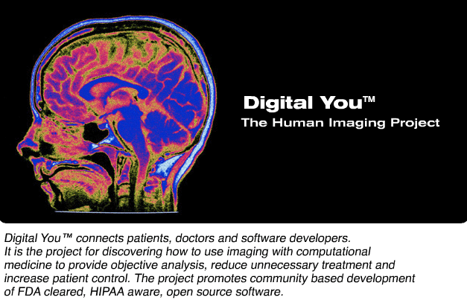
Increasing Options in Healthcare

Reconfiguring healthcare delivery to increase options and cut costs

Overview

Internet access to information is increasing healthcare options for patients and shifting the doctor-patient roles as the doctor becomes more advisor than controller. Currently, most Internet health care information is educational, i.e.: not specific to a particular patient. Patients appreciate the education but physicians are hard-pressed to deal with the added costs and risks of managing their newly empowered patients.

MedCommons an organization designed to improve U.S. healthcare through patient control of medical images. The structure and activities of MedCommons are designed to facilitate community participation in health care via the Internet. MedCommons will be significantly directed by its user community through their contribution of software code and data (e.g.: anonymized high resolution CT and MR scans). Via MedCommons Laboratories, the contributions of the more technically adept patients and physicians will be available to all patients and physicians. MedCommons introduces structure and methods to enable large-scale, patient-specific information analysis (often called Computer Assisted Diagnosis – CAD). As computer power and connectivity increase, CAD brings increasing sensitivity and objectivity to early detection and less invasive treatment of disease. A policy-level meeting with the FDA has determined that MedCommons open source software methods will comply with FDA regulations that apply to medical diagnostic software.

The founders of MedCommons believe that increased access to open, objective, peer-reviewed medical diagnostics in a structure that facilitates patient control will improve outcomes and reduce health care costs across all stakeholders in the healthcare system. The principal mechanism for these improvements is a reduction in the amount of inappropriate and unnecessary therapy that some studies claim wastes up to 30% of total health care expenditures.

Introducing MedCommons Laboratories (MCL) — a new class of Internet service provider

MedCommons Laboratories (MCL) innovation in Web services will provide Internet-based, medical-grade patient-specific information by to linking three groups:
- Affiliates - Disease specific web sites are the intended Affiliates of MedCommons Laboratories. For example, an MCL Affiliate Web site might offer advice and support around the screening process for breast, prostate or lung cancer where patients alerted to an abnormal imaging study or lab test already turn in search of options.
- Consumers - MCL will provide Web services infrastructure to the Affiliates that allows CAD use directly by patients and physicians acting as individual Consumers. MCL services will be free to patients and physicians. Although the patient and physician clearly have different roles, MCL analysis services will be blind to the distinction. The physician retains the key roles of structuring a diagnosis from possibly conflicting or incomplete MCL analyses and of acting as an intermediary to treatment.
- Sponsors - Patients using MCL services will have the option to voluntarily and anonymously request information from Sponsors with privacy guaranteed. Sponsors will include imaging centers, specialist medical providers, pharmaceutical companies and medical device manufacturers. They will support MCL Web services through payments for referrals.

Background: Information is Shifting Doctor-Patient Roles

The value of information in reducing risk is universal.

In healthcare, the management and monetization of risk takes many forms and is mediated by FDA regulations, marketing imperatives, and a variety of costly patient-to-physician and physician-to-physician relationships. Examples can be found in recent investigations of mammography screening practices, research showing the use of costly, self-referred “body scans” by patients to manipulate the managed care system and ongoing debates on reimbursement practices when multiple specialists consult on a single imaging study. When risk management breaks down, the results are felt throughout the system as malpractice suits (appropriate and frivolous), wasteful defensive medicine, and spiraling costs at every level of care.

Information growth is also universal.

At 80%, health information lags only email (93%) and product research (83%) as a reason for going online. The explosive growth of patient access to health information is not expected to slow. Access to sophisticated information is shifting the role of the patient from passive acceptor to empowered healthcare consumer. In response, the doctor's role is mutating from absolute authority to advisor. Common examples of this shift include:

- Growing payment for out-of-pocket “body scans” and other diagnostics to collect information.
- Patient collection of information from the Internet to use as a starting point for discussions about diagnosis and treatment.

In response, physicians find themselves:
- Forced to spend additional, uncompensated time addressing unordered diagnostic information and patient questions generated by Internet searches.

Since good information reduces risk and cost, restrictions on information access are not a cannot be a successful long-term strategy

The Internet has "let the information genie out of the bottle," and it's not going back in. Patients will find ways to circumvent any attempts to disempower them regarding their own healthcare.

The MedCommons solution

MedCommons is designed to feed the patient’s appetite for healthcare information specific to them and their situation with peer-reviewed and fully FDA regulated information. Specificity and personalization have historically been the exclusive domain of physicians and “the practice of medicine”. The Internet will not remove this exclusivity. What the Internet can do is to help change the role of the physician from authoritarian controller to a true learned intermediary.

Shared risk: Rebalancing the risk equation

From the patient’s point of view, the controller is responsible for both the information and the advice resulting from its analysis. An advisor, on the other hand, does not control what information is collected and analyzed but merely plays a role in sorting through possibly conflicting analyses to formulate the best treatment plan. The advisor can also reject inappropriate or low quality analyses. In any case, a shift from controller to advisor transfers some risk to the patient and away from the physician. Patient willingness to accept shared risk is evident in the persistent move toward alternate therapies and unapproved treatments.

Removing the incentives for waste

“Supplier induced demand” for care is increasingly mediated by direct-to-patient advertising and/or a regional surplus of health care facilities. MedCommons believes that increased access to patient-specific information will improve healthcare by accelerating innovation, facilitating safety and effectiveness regulation, and reducing unnecessary care.

MedCommons: Revitalizing Healthcare through Patient Control

MedCommons is a new technological and market-based approach that enables patients to control their personal health information and to access the most powerful computer-assisted analyses of their specific medical status.

MedCommons focuses on diagnostic technology and the analyses that contribute to a diagnosis because improved diagnostic information provides powerful leverage to concurrently reduce risk and unnecessary therapy. MedCommons new, patentable method simultaneously enables both patient control and rapid technological advances in diagnostic analyses without compromising safety, quality of service, or the valuable role of the physician as advisor.

MedCommons innovations include:
- The use of peer-reviewed, FDA-regulated Open Source software
- A unique collaboration between patient communities
- A new class of Internet service laboratories
- Further realignment of patient and physician roles.

Significant and durable benefits to all stakeholders

Reduced costs

Health care costs will be reduced directly through reduced technology costs and, more important, indirectly through a reduction of unnecessary care. Patients will benefit from more open, scientifically peer-reviewed and less conflicted diagnostic technology. In addition, those patients who wish to make use of every option available for their own healthcare decisions will be able to control their interaction with physicians, pharmaceutical companies, and medical device companies to a greater extent than ever before.

MCL avoids substantially all risk

Physicians, hospitals and vendors share malpractice risk in healthcare. Although vendors such as MedCommons Laboratories are rarely sued, adherence to accepted standards, formal processes and care in working within FDA regulations will allow MCL to grow to national scale. Like today’s traditional large medical laboratories, MCL depends on others (e.g.: nonprofit Affiliates and commercial medical device vendors) – to develop and seek FDA registration for CAD technology.

The MedCommons method makes it possible for MCL to avoid substantially all of the risk of providing sophisticated computerized analysis of advanced patient-specific information (e.g., CT, MRI, genetic scans). Blinded, anonymous, computer analysis of patient information is, by definition, objective. To the extent that the analysis software is open source and subject to peer review, the risk of commercial bias is also significantly reduced. This evidence-based and outcomes-driven approach to treatment decisions will result in treatments that more closely reflect patient preference while reducing “supplier induced demand”. The MedCommons method creates a relationship between MCL, Affiliates and Consumers in a sustainable manner that fits within existing FDA medical device regulations.

Free to patients and physicians

The virtual elimination of risk for MCL allows the highest quality services to be free to both patients and physicians while deriving profit from the patient’s voluntary activities in deciding which imaging center to use, which pharmaceutical to consider and which physician to consult.

MedCommons Affiliates, in the form of disease-oriented Internet communities and the software developers that they attract, will develop much of the software that is used for analysis of patient-specific medical information. Many Affiliates will be derived from today’s charity-supported organizations. They will employ, scientifically preferred open source software community development methods to increase innovation of sophisticated and increasingly valuable analyses.

A New Class of Internet Service Laboratories

Bringing increased options to patients through community participation is a market-based solution to many currently intractable political and regulatory challenges. MedCommons and MCL are, respectively, the non-profit and commercial aspects of the MedCommons Internet solution.
Non-profit MedCommons will focus the interaction of community based Affiliates, and will be coordinated with the introduction of
MCL, the commercial arm, which will provide medical information processing services to patients and provide a transparent conduit for support by wide range of Sponsors ("transparent conduit for support" is very vague language. Be specific).

Research on this combined approach is represented by the work of Siobhán O'Mahony at Harvard Business School.

MedCommons is a medical laboratory business

MCL will be a start-up medical laboratory business with both venture and strategic corporate funding. Initial corporate support is anticipated from major health care systems and services vendors that wish to participate in Web services development for both traditional and new health care customers. We expect MedCommons to be hosted at a research university working at the intersection of health sciences, software methods, and health care policy.

MedCommons seeks $2 million to launch the organization and fund it for the first year. The initial scope of MCL is to provide patient-specific services over the Internet on a commercial basis and as such, MCL will require separate capital formation.
MCL Services

Anonymous Medical Image and Data Analysis

A high quality, data-centric Web Services Business (“Amazon for Healthcare”)

Using Open Source, Peer-Reviewed Methods as available

Exposes Web Services Interface to thousands of Disease-Oriented Affiliates

Accepts images and returns annotated images with absolute Patient Control

Free to the Patient and Physician

Patient Opt-in for Imaging Center Referral

MedCommons compliant Imaging Centers listed geographically

Imaging Center Pays for Referrals

Patient Opt-in for Pharma / Device Referral

Manufacturer Pays for Referrals

Physician / Patient Opt-in to DigitalYou™ Curated Data Bank

Free to Physicians and Manufacturers

Pro-Forma Clinical Analysis Menu

Diabetic Retinopathy Screening

Lung Cancer Screening

Coronary Calcium Scoring

Virtual Colonoscopy

Abdominal Aortic Aneurysm Treatment Planning

Tumor Volume Measurement

Mammography Screening

Radiation Treatment Planning

EKG Interpretation

Holter Monitoring

Step-by-Step Description

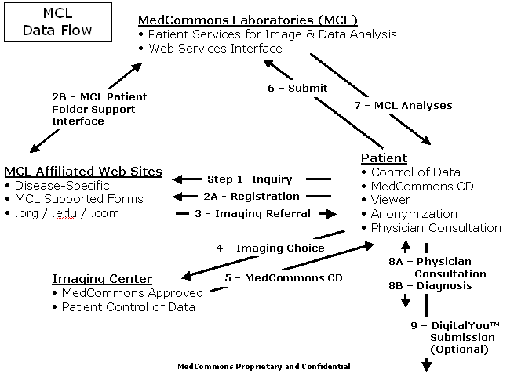
NOTES:

Step 1 – An MCL Affiliated Web Site does not have to store or process any patient-specific data. MCL-aware Web pages interact with MCL Web Services that provide Patient Folder support in a reliable and fully customizable manner.

4 - The Imaging Center choice is a Patient Opt-In. MedCommons Approved facilities always return images to the patient in a manner that allows the patient and their physician full HIPAA-mandated control over all subsequent uses of the images.

7 - MCL Analyses may offer Patient Opt-In to highly targeted solicitations from pharmaceutical and medical device manufacturers. The use of anonymity and Open Source software guarantees Patient Control and maximum privacy.

8 - Consulting physicians can use the same free software that MedCommons makes available to the Patient. However, because MedCommons software is Open Source, physician software vendors will have no barrier to incorporating MedCommons and MCL Web Services technology into their professional products.

9 - DigitalYou™ is the MedCommons trademark for The Human Imaging Project that includes the universe of images and evidence-based diagnostic conclusions that patients and their physicians have voluntarily donated to the public commons. DigitalYou™ data will be curated and stored by a variety of academic, charitable and commercial users to assist in the development of ever more sophisticated Computer Assisted Diagnosis (CAD) software and services.
Benefits

Health Care Waste Reduction

30% of care is Unwarranted

Increased Diagnostics Access

Decreased Therapy Costs

Increased Transparency, Privacy, Innovation, and Peer-Review

Market-based Control of Direct-to-Consumer Advertising

Team

Co-Founders

Adrian Gropper, M.D.

Hugh Cottingham

Sean Doyle

Management

TBD

Medical Device Professionals

FDA 510[k] Experience

Teleradiology Experience

Open Source Software Expertise

MGH Affiliation

Plan

MedCommons Laboratories.com

Online Patient Services

Computer and Storage Operations (Outsourced?)

MedCommons.org

Leadership in Patient Control

Trademark management

FDA Registration Methods

Mitigates the Risk of Advanced Computer Technology

Demonstrates Community-based Free/Open Source Software Development for Healthcare

Oversight

MGH

MIT

Clinical Trials Consortia

Potential Sponsors

HP

IBM

Analog Devices

Novell

 Executive Summary July 2003

Vision
Improve U.S. healthcare through patient control of medical images.

Market Strategy
MedCommons will be the first non-profit organization to develop and distribute FDA cleared, Open-Source, medical web services applications for individuals and physicians. MedCommons will be directly supported by one or more for-profit ventures that benefit from direct patient control of medical information. These include diagnostic imaging systems manufacturers, pharmaceutical and minimally invasive therapy manufacturers and Internet providers of automated image interpretation laboratory services.

Opportunity
Medical imaging is now an integral and growing part of modern health care. Currently, there is often no way for patients to access their digital medical images (CT, MR, etc.) without a lot of bureaucratic red tape. Not being in control of their medical images results in patients experiencing unnecessary difficulty when dealing with complex medical situations and difficulty in getting objective information about their treatment options. Patient control of medical images, through effortless portability across institutional boundaries, will eliminate these difficulties and enable emerging computational medicine web services. This will offer the patient the possibility of separating diagnosis from treatment decisions, along with enhancing the role of the primary care practitioner as patient advisor, for treatment that is more fully aligned with the patient’s best interests and wishes.

Mission

Digital You™, The Human Imaging Project connects patients, doctors and software developers. It is the project for discovering how to use imaging with computational medicine to provide objective analysis, reduce unnecessary treatment and increase patient control. The project promotes community based development of FDA cleared, HIPAA aware, open source software.

Business Strategy
Open Source software has a natural advantage in applications where both customers and suppliers benefit from a non-proprietary platform. The rapid market acceptance of Linux and its support by IBM illustrate this point. Medical software, however, requires FDA clearance appropriate to its intended use and distribution. MedCommons will be a market leader, known to define, implement and promote an Open Source platform for medical applications. Digital You™ software and MedCommons protocols are designed to support the full range of emerging computational medicine services whether delivered as Web services, Open Source or proprietary software to patients and physicians alike.

Organization Strategy
Non-profit. On going software registration services and support operations will be supported by referral fees paid by pharmaceutical, medical device and laboratory services vendors. MedCommons will contribute to strategically important open source diagnostic software developers including universities and academic medical research centers.

Financials
MedCommons is seeking $2 million in sponsor funding to launch the organization and fund it for the first year.

Appendix B: MedCommons DigitalYou™

DigitalYou™ connects patients, doctors and software developers. It is the project for discovering how to use imaging with computational medicine to provide objective analysis, reduce unnecessary treatment and increase patient control. The project promotes community based development of FDA cleared, HIPAA aware, open source software.

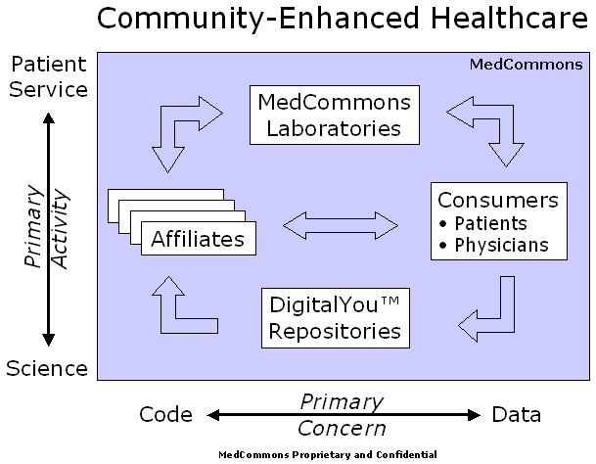

MedCommons will be organized and operated as a not-for-profit, and affiliated with one or more major scientific organizations interested in bringing medical scientific advances to patients as quickly as possible. MedCommons will develop methods for development and distribution of Open Source Software that conform to FDA medical device regulations. MedCommons will enable community-enhanced healthcare by lowering the regulatory barriers that are unique to high-risk healthcare software such as that used for screening and treatment planning.

Through DigitalYou™, MedCommons will promote medical science by making it much easier and more rewarding for patients and physicians to contribute their increasingly valuable high-resolution data sets to the global library of genotypic and phenotypic information. DigitalYou™ Repositories will benefit from the growing catalog of open software and open science projects spawned by the Human Genome Project. A positive feedback effect is anticipated, as this free library is essential to the development of more effective computer assisted diagnosis programs.

ADRIAN GROPPER, M.D.

Adrian has pioneered the use of computers and the Internet to deliver diagnostics to all physicians. For over 25 years, Adrian has used a combination of engineering and medicine to transition sophisticated diagnostics out of the specialist’s lab and into everyday practice. Today, he’s at the forefront of making diagnostics accessible directly to patients over the World Wide Web.

Adrian’s career as a medical device developer began with undergraduate education in mechanical engineering and computer simulation at MIT, research on early diagnosis of lung disease at the Harvard School of Public Health, graduation from Harvard Medical School in 1978 followed by internship at the University of Oregon Health Sciences Center.

Beginning with a position as Director of Biomedical Research at Orion Research, Inc, Adrian pioneered the field of “physician’s office” diagnostics with the first whole blood analyzer designed for use outside of a laboratory setting. The Orion 1020 introduced the use of embedded computers for fool-proof operation and quality control thereby enabling FDA clearance of a highly sophisticated device outside of a laboratory. Descendants of the 1020 design are still manufactured today by most of the suppliers in the blood electrolyte marketplace.

In 1983, Adrian established his entrepreneurial career as the co-founder of Analytix, Inc. The company developed the first robotic blood analyzer and had an IPO in 1986. In the early 1990’s as the global threat of AIDS became clear, Adrian, working with the leading HIV diagnostic test supplier developed the first low cost, hand-held HIV tester for the developing world.

Adrian’s work on imaging and affiliation with Massachusetts General Hospital began in 1991 with early work on the Center for Innovative Minimally Invasive Therapy a joint project of the MGH departments of radiology and surgery. Over the next few years, Adrian was responsible for the design and deployment of a number of pioneering telemedicine projects throughout the world and, as Chief Technology Officer of RSTAR, Inc, the genesis of the first generation of commercial diagnostic Picture Archiving and Communications Systems (PACS).

In 1995, Adrian Gropper and Sean Doyle founded AMICAS Inc, to bring diagnostic quality images to physicians outside of the radiology department PACS by using Internet technology. AMICAS’ 1997 FDA-clearance of its flagship product preceded the next Web-based image management system by some 18 months. Today, AMICAS’ Web-based PACS technology is installed in over 125 hospitals for use by both radiologists and other physicians. The list of hospitals includes such flagships as MGH, Boston Medical Center, New York Presbyterian and Cornell Medical Centers and The University of Chicago.

From the Orion 1020 to the AMICAS Web PACS, Adrian’s career has consistently pursued the use of computer technology to demystify and remove subjective interpretation from the most broadly applicable diagnostics. Cooperation with and respect for the FDA mandates for advanced diagnostics have been a consistent element of all of his designs as he continues to “push the envelope” in advancing the scientific practice of medicine.

Hugh Cottingham

Sean Doyle

The End of the Middle
David S. Isenberg
Opinion; IEEE Spectrum; January 2003

This short essay explains the key market strategy behind MedCommons Laboratories. Like the Internet itself, an extensible and impartial infrastructure for patient services can promote rapid innovation in healthcare.



Annals of Internal Medicine; February 18, 2003; http://www.annals.org/issues/v138n4/toc.html
Internet Health Resources; Pew Internet and American Life Project, July 16, 2003; www.pewinternet.org
The Organizational Model for Open Source; HBS Working Knowledge; July 7, 2003; http://hbsworkingknowledge.hbs.edu/pubitem.jhtml?id=3582&t=nonprofit

